How to Get Journal Articles

YES  
Your article is in print!

* Shelved alphabetically by title

Current issues, 1st floor  
 Old issues, 2nd floor

* Check the holdings info to make sure the volume you need is available.

NO  
Use the Interlibrary Loan (ILL)  
listed on  
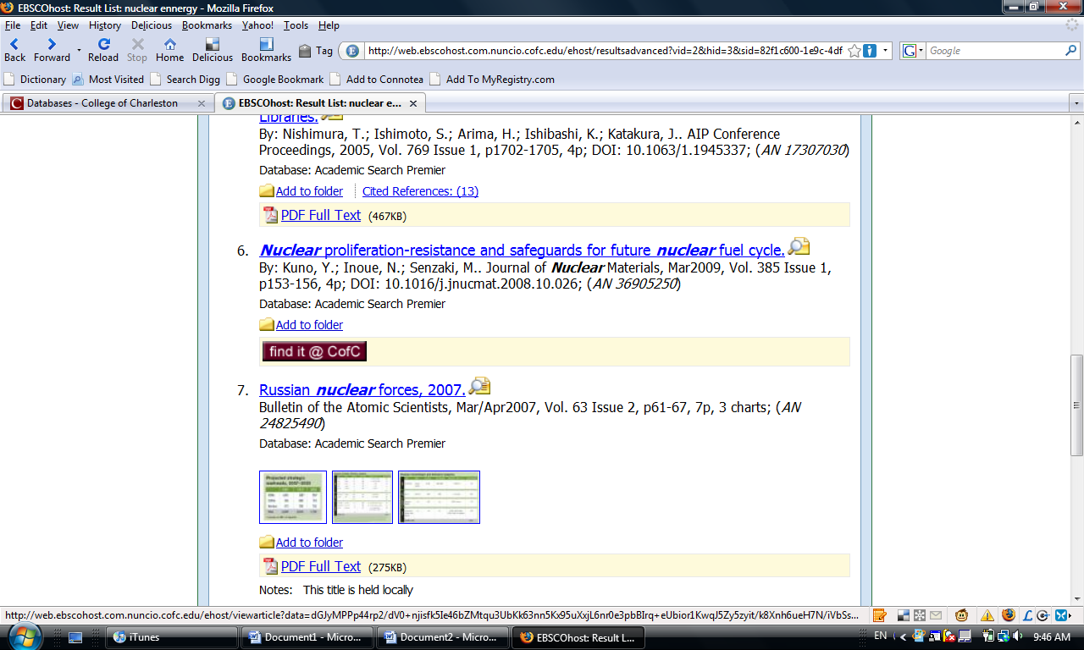Menu  
and   
CofC Libraries web site   
to request the article.   
Pick up the article at the Research & Info Desk.

NO

Click the link:   
Find Journal Name in CofC Libraries Catalog  
Is it listed?

No Full Text Available

Full Text available from Resource Name

Your article is online,   
a click away!   
Follow the link to print it out.

Click thebutton to see if the article is available online.   
Which message do you see?

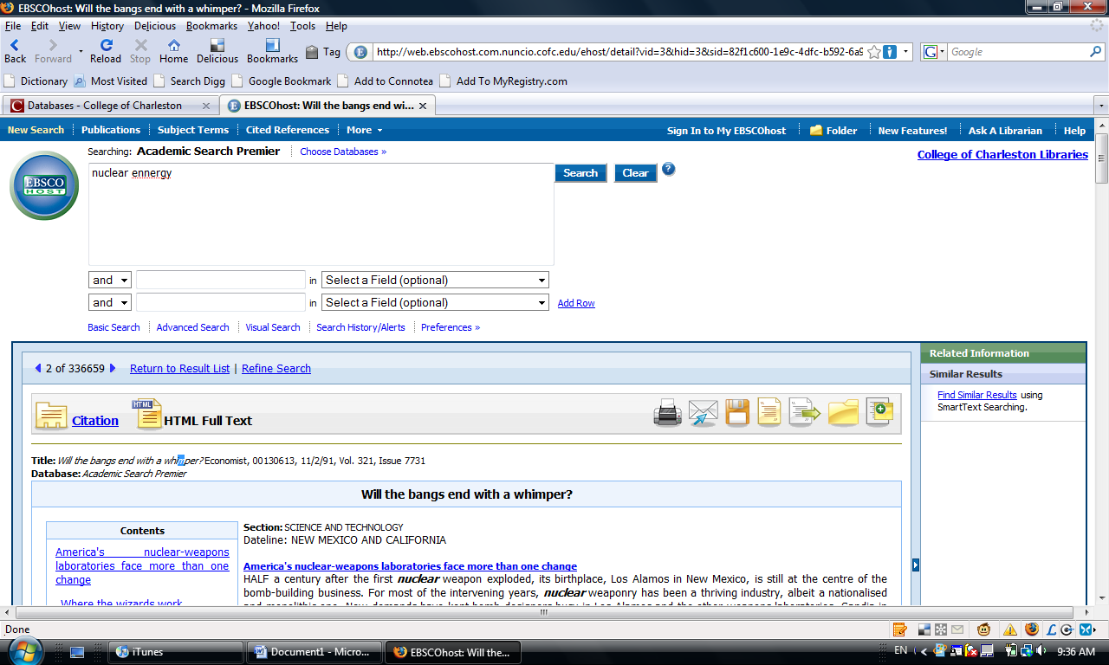  
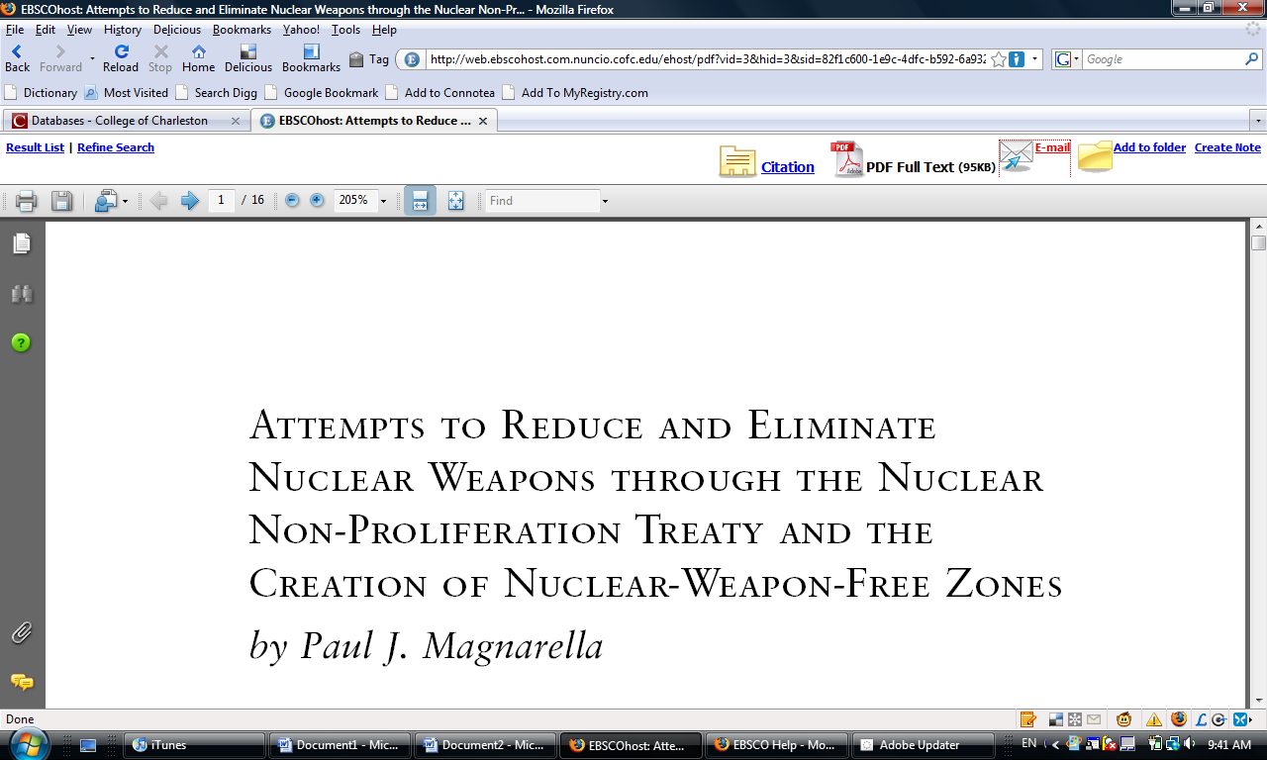  
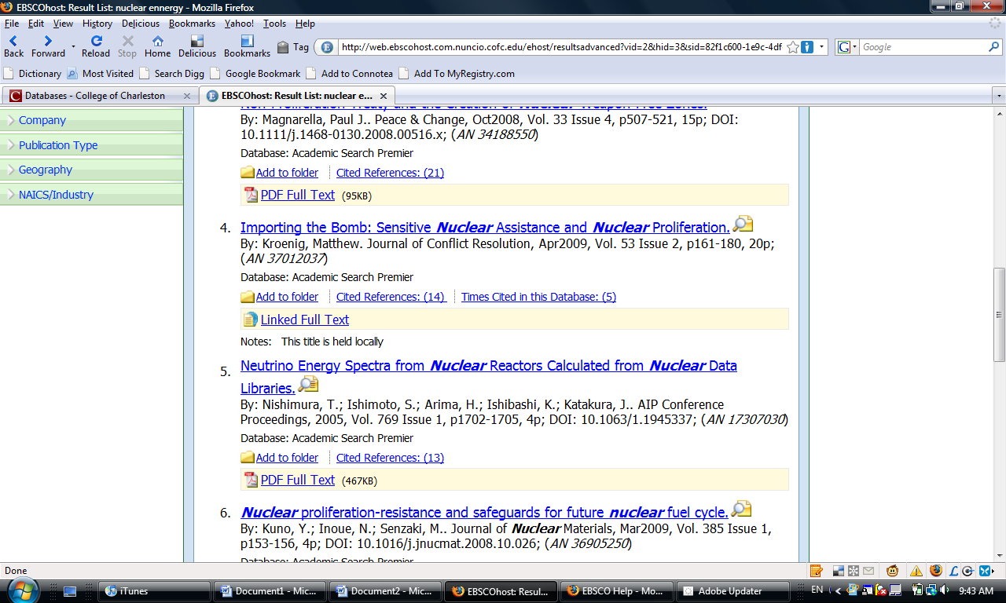



Search Databases for Article  
Do you see a link like one of these?

Ask A Librarian  
<http://www.cofc.edu/library/find/ask/>  
chat, IM, email, phone